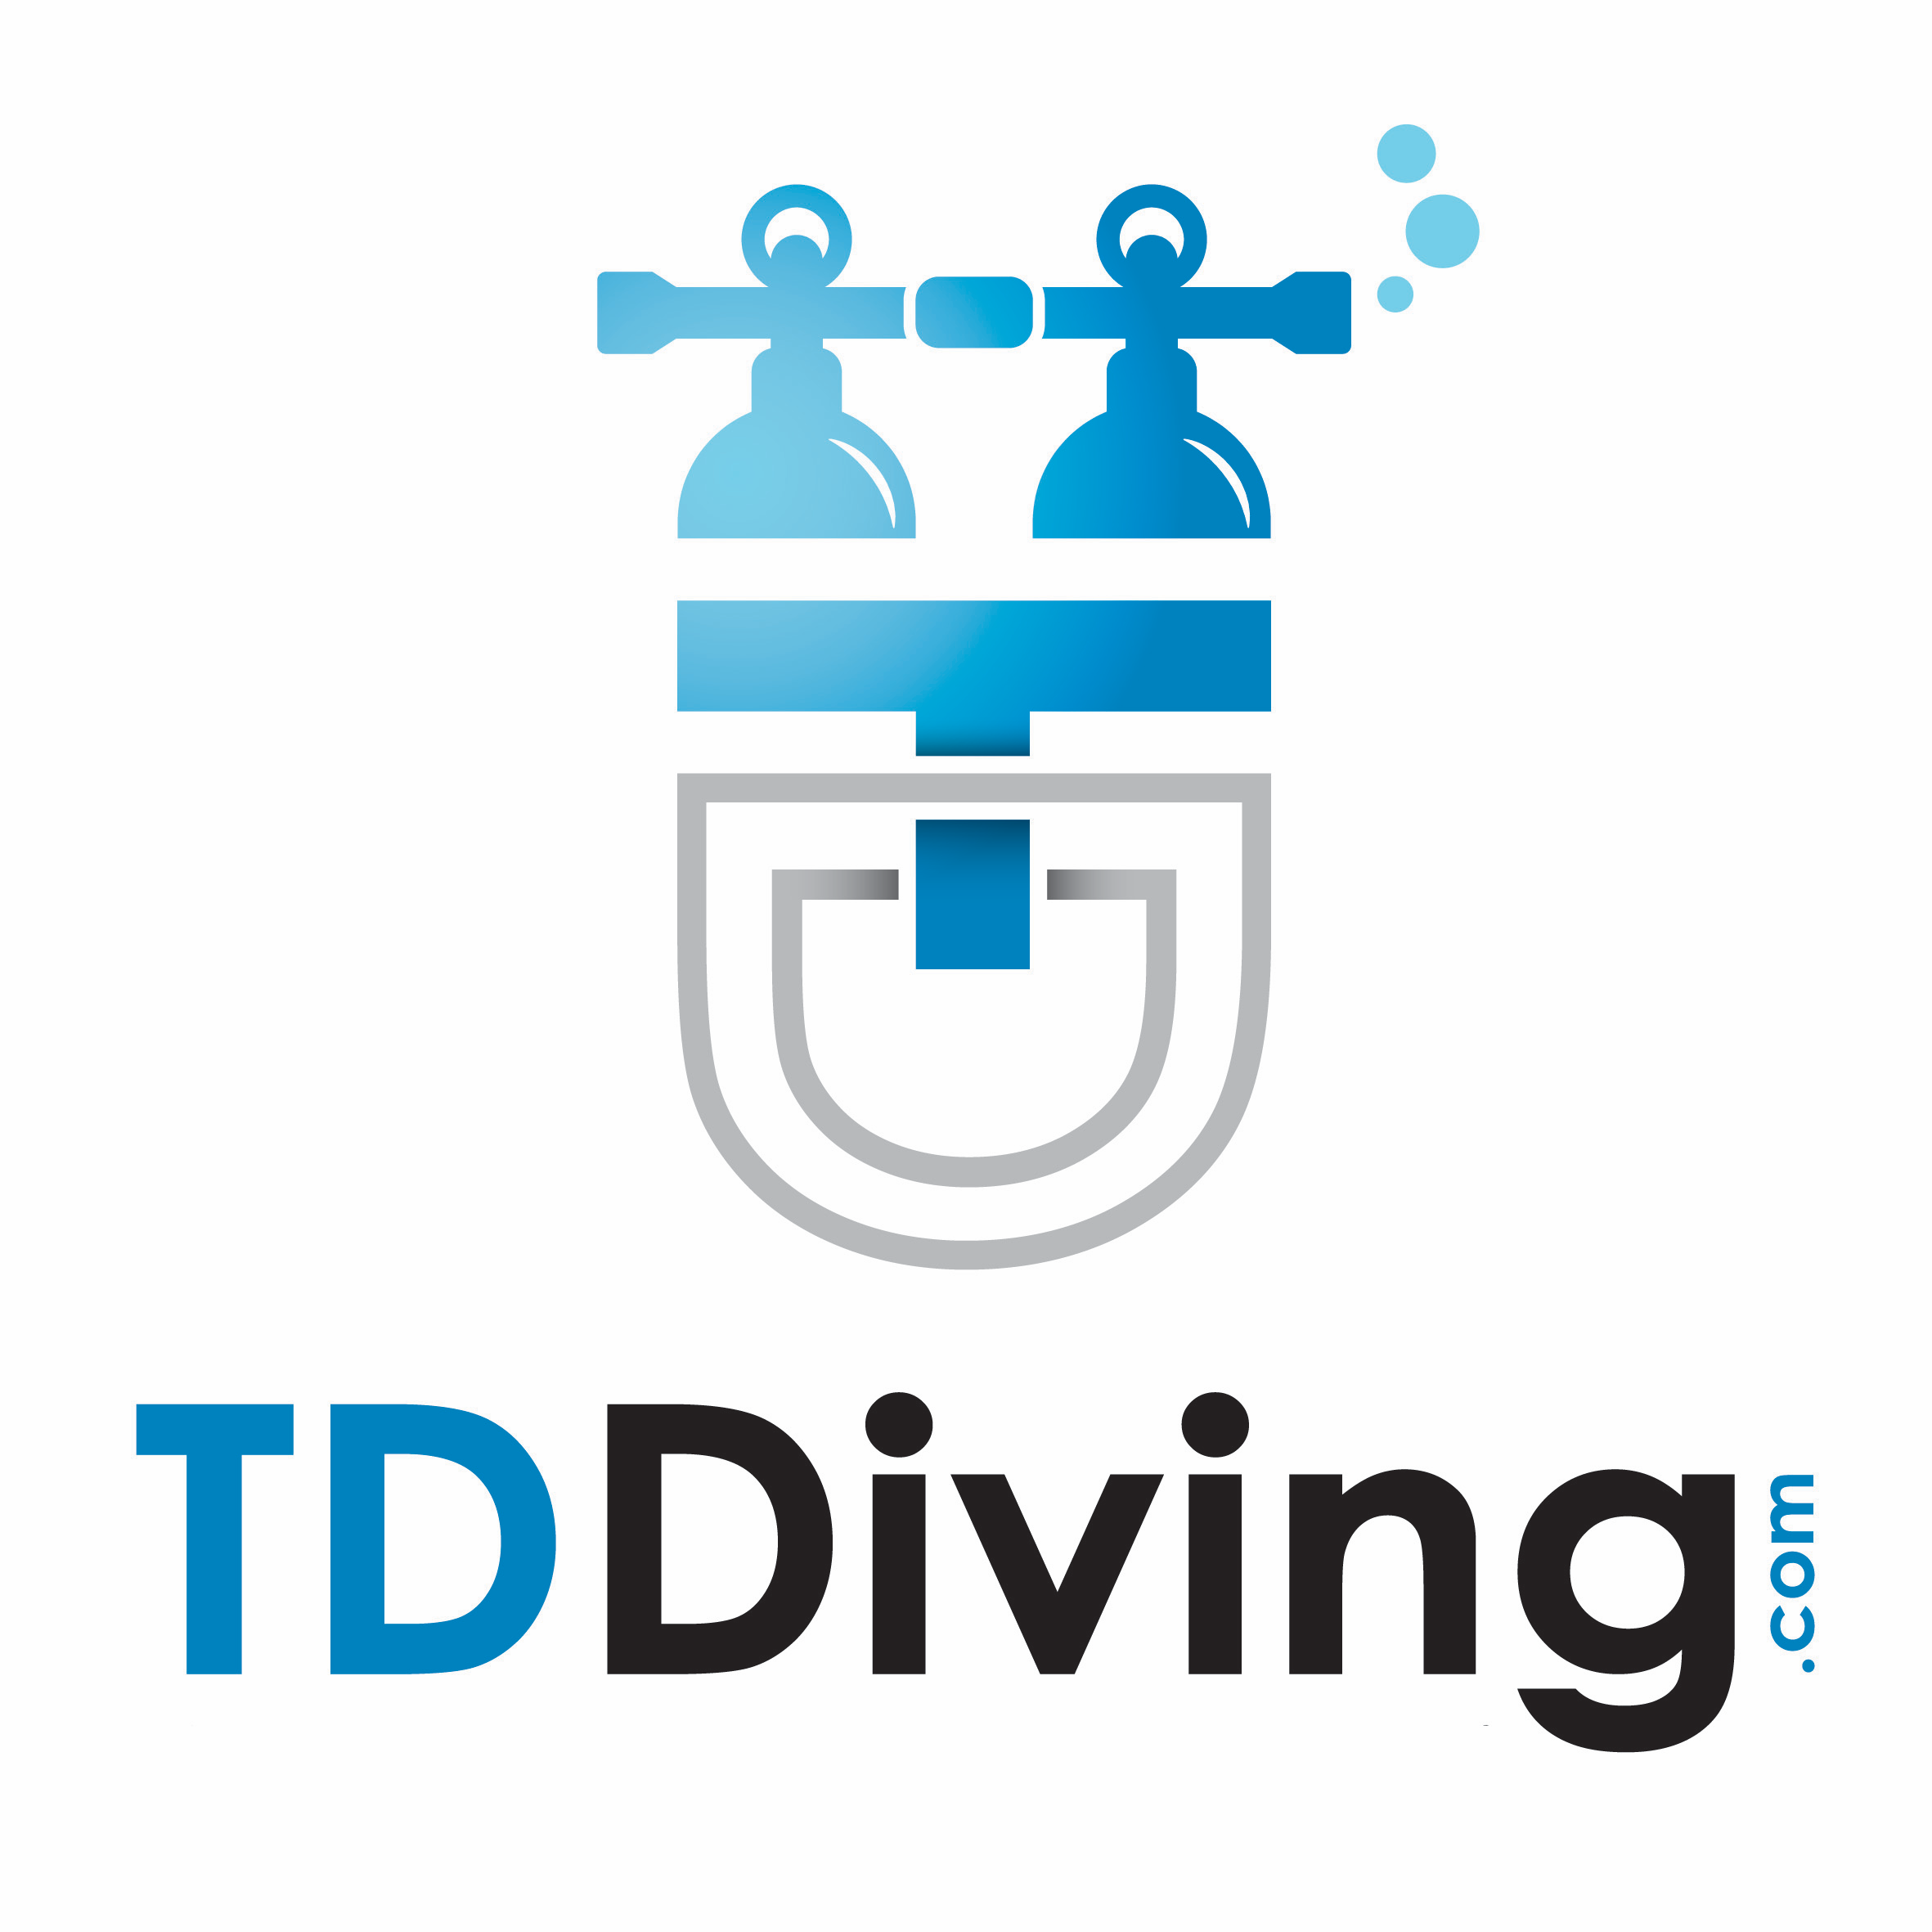

SCUBA COURSES

SDI | €
Future buddies | 75
Scuba discovery | 75
Open water scuba diver | 400
Advanced Adventure diver | 350
Computer Nitrox Diver Specialty | 99
Deep Diver Specialty | 199
Wreck Diver Specialty | 199
Search & Recovery Diver Specialty | 199

TDI | €
Nitrox | 185
Intro to Tech | 199
Advanced Nitrox | 399
Decompression Procedures | 399
Combo: Advanced Nitrox & Decompression | 735

PADI | €
Bubblemaker | 75
Discover Scuba Diving | 75
Scuba Diver | 280
Open Water Scuba Diver | 400
Adventure Diver | 300
Advanced Open Water | 380
Rescue Diver | 400
EFR | 180
Divemaster | POA
Nitrox Specialty | 99
Wreck Specialty (with 2 Zenobia Dives + 2 Limassol) | 350
Deep Specialty (with 2 Zenobia Dives + 2 Limassol) | 350
Night Diver Specialty | 300
02 Provider Specialty | 99
Equipment Specialist | 150
Search & Recovery Specialty | 350

TRIPS (excludes equipment)

Location | €
Local Shore Dive | 45
Discover Scuba Diving Trip (2 dives) | 95
Akrotiri (2 dives) | 95
Cape Greco (2 dives) | 125
Limassol Wrecks (2 dives) | 95
Coral Bay (2 dives) | 125
St George’s Island (2 dives) | 150
Jubilee Shoals (2 dives) – simply amazing (AOW+) | 150
Zenobia (2 dives) | 130
Night dive (1 local shore dive) | 55

Dive Packages (excludes equipment)
4 Dives (includes 2 Zenobia Wreck dives) 225
6 Dives (includes 2 Zenobia Wreck dives) 280
8 Dives (includes 2 Zenobia Wreck dives) 320
10 Dives (includes 2 Zenobia Wreck dives) 350

Equipment Hire (per day)
Full Kit (fins, mask, boots, BCD, wetsuit, tank –air) 30
Torch 5
Dive computer 10

Gas Fills

Air €
3 Litre 4.00
10 Litre 4.00
12 Litre 5.00
15 Litre 5.00
18 Litre 5.00

Nitrox Standard Mix (28% - 30%)* €
3 Litre 5.00
10 Litre 5.00
12 Litre 5.00
15 Litre 9.00
18 Litre 13.00

Nitrox 50% €
7 Litre 12.00

Nitrox 80% €
7 Litre 20.00

Air €
10 Litre Twins 10.00
12 Litre Twins 10.00
15 Litre Twins 12.00
18 Litre Twins 12.00

Nitrox Standard mix (28% - 30%)* €
10 Litre Twins 12.00
12 Litre Twins 12.00
15 Litre Twins 20.00
18 Litre Twins 28.00

O2 €
2 Litre 8.00
3 Litre 12.00

Gases €
Oxygen .02 per litre
Nitrox ≥ 30% POA
Trimix / Helitrox fills .08 per litre

Does not include cylinder hire at €5.00 or €7.00 per cylinder per day as appropriate
*Add €2.00 per cylinder for non-standard mixes
** Discounts can apply. Please inquire

