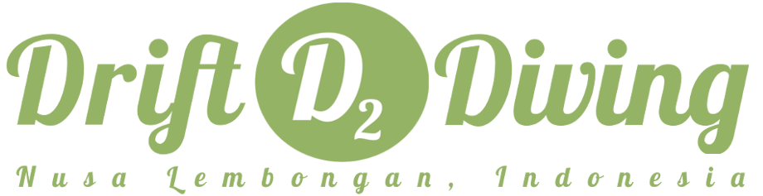

FUN DIVES* IDR
2 Fun Dives in one trip 900.000
1 Fun Dive 600.000
8 Fun Dives or more in 2 FD per trip 10% discount
Scuba Review + 300.000
DISCOVERY SCUBA DIVING
1 dive 950.000
2 dives 1.200.000
ADVENTURES IN DIVING
1 Adventure in Diving + 1 Fun Dive 1.200.000
COURSES
Open Water Course (3-4 days) 4.900.000
Advanced Open Water Course (2-3 days) 4.000.000
Emergency First Response Course (1 day) 2.500.000
Rescue Course (3-4 days) 4.900.000
SNORKELING
Snorkelling trip 250.000

DIVER LOG BOOK 100.000
TANK BANGER 150.000

*All prices include all the gear and lunch, coffee, tea and water on the boat.
Except for one dive trip is NOT included lunch, coffee and tea.

**We charge 200.000 rupiahs EXTRA per person to go to MANTA POINT and SAMPALAN!!!

