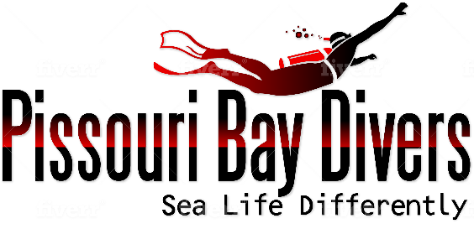

2020 PRICE LIST
SKIN DIVER from €25 per hour (min 2 people)
BUBBLEMAKER €60
DISCOVER SCUBA DIVING €80 Same day follow up dive €40
SCUBA DIVER €320 SD to OW upgrade €250
OPEN WATER DIVER €450 Referral €250
ADVENTURE DIVER €260
SPECIALITIES from €100
ADVANCED OPEN WATER DIVER €340 with Zenobia €450
RESCUE DIVER €490
EMERGENCY FIRST RESPONSE €125
EMERGENCY OXYGEN PROVIDER €50

DAY TRIPS – INCLUDING 2 X BOAT DIVES, ALL KIT, TRANSFERS & BOAT FEES

ZENOBIA & ELPIDA from €140 non divers €50 (including BBQ)
LADY THETIS &
COSTANDIS €120
Many more boat dives, ask our helpful staff for details

DIVER PACKAGES FULL KIT TANK & WEIGHTS
1 DIVE (min 2 people) €45 €40
2 DIVES €85 €80
3 DIVES €120 €110
4 DIVES €160 €150
5 DIVES €200 €190
6 DIVES €240 €230
7 DIVES €280 €270
8 DIVES €320 €310
9 DIVES €360 €350
10 DIVES €400 €390

NIGHT DIVES From €60 x 1 dive

